**SPL-1 Project Report, 2019**

**Photo Editor**

**SE 305: Software Project Lab 1**

Submitted by

***[Md. Ahasanul Islam]***

**BSSE Roll No.: 1024**

**BSSE Session: 2017/18**

Supervised by

### [Mohd. Zulfiquar Hafiz](http://www.iit.du.ac.bd/about_iit/individual_teacher/20)

**Designation: Professor**

**Institute of Information Technology**



**Institute of Information Technology**

**University of Dhaka**

[29-05-2019]

Table of Contents

1. Introduction …………………………………………………………………………………………………………………. 5
   1. Background study ………………………………………………………………………………………………….. 5
   2. Challenges ……………………………………………………………………………………………………………… 6
2. Project overview ………………………………………………………………………………………………………..… 6
   1. Filters …………………………………………………………………………………………………………………….. 6
      1. Sepia …………………………………………………………………………………………………………. 6
      2. Black and White ……………………………………………………………………………………..…. 7
      3. Grayscale ………………....................................................................................... 8
      4. Solarise ……………............................................................................................. 9
      5. Negative………………………………………………………………………………………………………10
      6. Mirror ……………………………………………………………………………………………………….. 11
   2. Crop………………………………………………………………………………………………………………… ……..12
      1. Square Crop…………. ………………………………………………………………………………….. 12
   3. RGB Adjustment …………………………………………………………………………………………………….. 13
      1. Red ……………………………………………………………………………………………………………. 14
      2. Green ………………………………………………………………………………………………………… 15
      3. Blue ……………………………………………………………………………………………………….….. 16
      4. Yellow ……………………………………………………………………………………………………….. 17
   4. Brightness ……………………………………………………………………………………………………………... 18
3. User Manual …………………………………………………………………………………………………………………. 19
4. Conclusion ……………………………………………………………………………………………………………………. 20
5. Appendix ……………………………………………………………………………….……………………………………… 20

References ……………………………………………………………………………………………………………………. 21

List of figure

1. Main page ………………………………………………………………………………………………………………..………… 6
2. Sepia image ………………………………………………………………………………………………………………..……… 7
3. Black and White …………………………………………………………………………………………………………..…….. 7
4. Grayscale ……………………………………………………………………………………………………………………….….. 8
5. Solarise …………………………………………………………………………………………………………………………….… 8
6. Negative …………………………………………………………………………………………………………………………... 11
7. Blur …………………………………………………………………………………………………………………………………... 12
8. Mirror ………………………………………………………………………………………………………………………………. 12
9. Red …………………………………………………………………………………………………………………………………… 16
10. Green ……………………………………………………………………………………………………..………………........... 16
11. Blue ……………………………………………….…………………………………………………………………………………. 16
12. Yellow ……………………………………………………………………………………………………………………..........… 18
13. Brightness …………………………………………………………………………………………………………....…........… 18
14. Crop ……………………………………………………………………………………………………………………............... 19
15. Open file chooser …………………………………………………………………………………………………..........…. 19
16. Open image …………………………………………………………………………………………………………….......….. 19
17. Filtered image …………………………………………………………………………………………………………………... 20
18. Save file chooser …………………………………………………………………………………………………………....... 20

List of Table

1. Original pixel ……………………………………………………………………………………………………..……………. 14
2. Crop image…………….………………………………………………………………………………………………………… 14
3. Class description ……………………………………………………………………………………………………………… 21
4. **Introduction**

The subject of my project is "Photo Editor" It's part of the processing of images. Image Processing is the art and science of digital image manipulation. It stands firmly in mathematics with one foot and in esthetics with the other and is a critical component of graphical computer systems.I've got some filters, and the filters are sepia, black and white, gray, negative, blur solarization, mirror, cropping, brightness. In addition to this image, its red, green, blue and yellow image is also  processed.

My goal is to give a clear view of the photo editing ideas that can be given to an  image to change its original appearance. By acquiring motivations from various  existing software, I select this topic as my project. When I started this project, I  used intellij as a support software.

* 1. **Background Study**

Background study is the first phase when the preliminary investigation is  conducted for software development.

JavaFX is a software platform that can run across a wide variety of devices to create and deliver desktop applications, as well as rich Internet applications (RIAs). JavaFX is intended to replace Swing as the standard Java SE GUI library, but for the foreseeable future both will be included.

Java offers many ways of working with the image. Image filters start with color concept. The primary color system used by java is RGB (Red, Green and Blue). A pixel is an image's smallest graphical component and a specific color is assigned. Each pixel in an image has a specific color that is usually described using RGB color system. Java provides support for working with 32-bits image. Each pixel in an image is described using 32-bits. The red, green, blue components are stored in these 32 bits along with alpha component. The alpha component refers to the transparency of the pixel.

A 32-bit java image pixel therefore consists of red, green, blue and alpha  components. Each component has a value of 8 bits between 0 and 255. The value of the color component 0 means that the component is absent and 255 means max. Since the alpha component describes transparency / opacity, the  value 0 means complete transparency and 255 means complete opacity.

|  |  |
| --- | --- |
| Color | RGB value |
| Black | (0, 0, 0) |
| White | (255, 255, 255) |
| Red | (255, 0, 0) |
| Green | (0, 255, 0) |
| Blue | (0, 0, 255) |
| Yellow | (255, 255, 0) |

* 1. **Challenges**

Going through project it is obvious that I would face a problem and challenges. At the beginning of the project I was unknown about GUI and my project all depends on GUI. So, working on GUI was my one of the challenge. Working in photo filters is itself a challenging process. We need to manipulate each and every pixel of image.

Besides that working with filters like crop, brightness, mirror, blur was one of the challenging. Changing crop and brightness with slider was another challenge.

1. **Project Overview**

First of all, image is read from file. FileChooser is used to select image and displayed on Open. There are used achorpane, Button, Hbox, ImageView for displaying original image and other for filtered image.

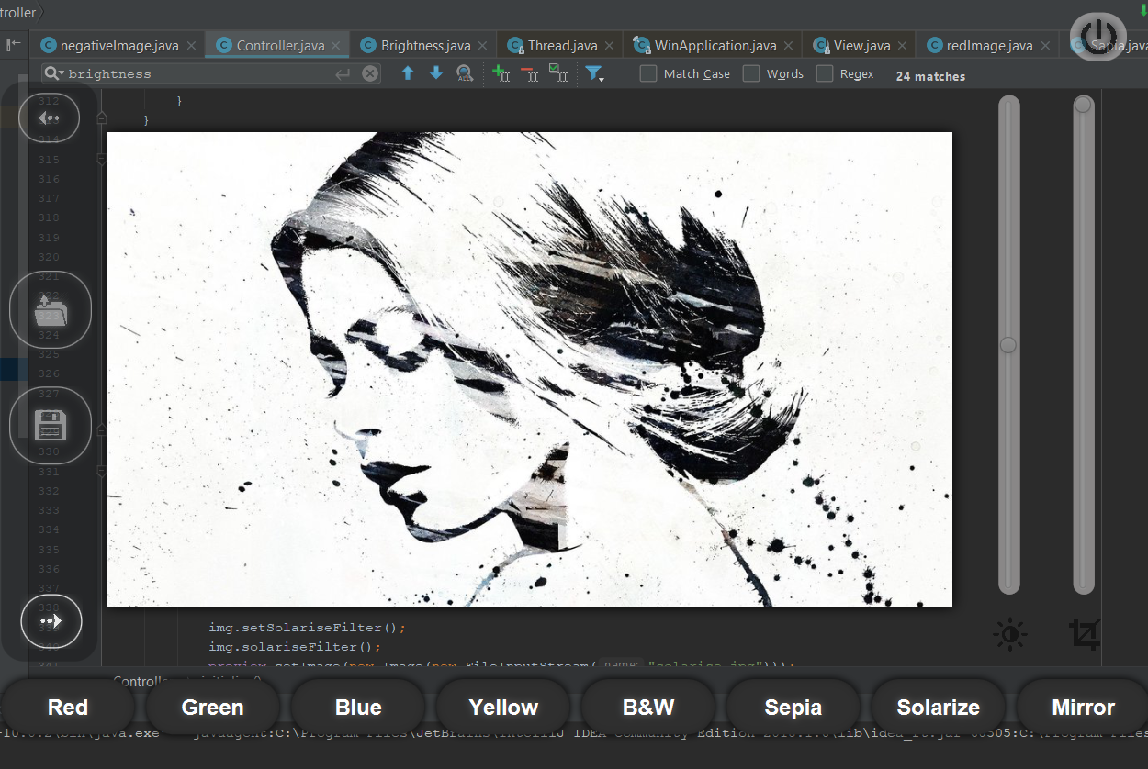

Fig1: Main page

* 1. **Filters** 
     1. **Sepia**

Sepia is a burnt color tone filter available as an editing option. The red, yellow and brown tones associated with sepia bring warmth to photos. We need to get RGB value of the pixel and set the new RGB value by using below value.

int tr = (int) (0.393 * r + 0.769 * g + 0.189 * b);  
 int tg = (int) (0.349 * r + 0.686 * g + 0.168 * b);  
 int tb = (int) (0.272 * r + 0.534 * g + 0.131 * b);

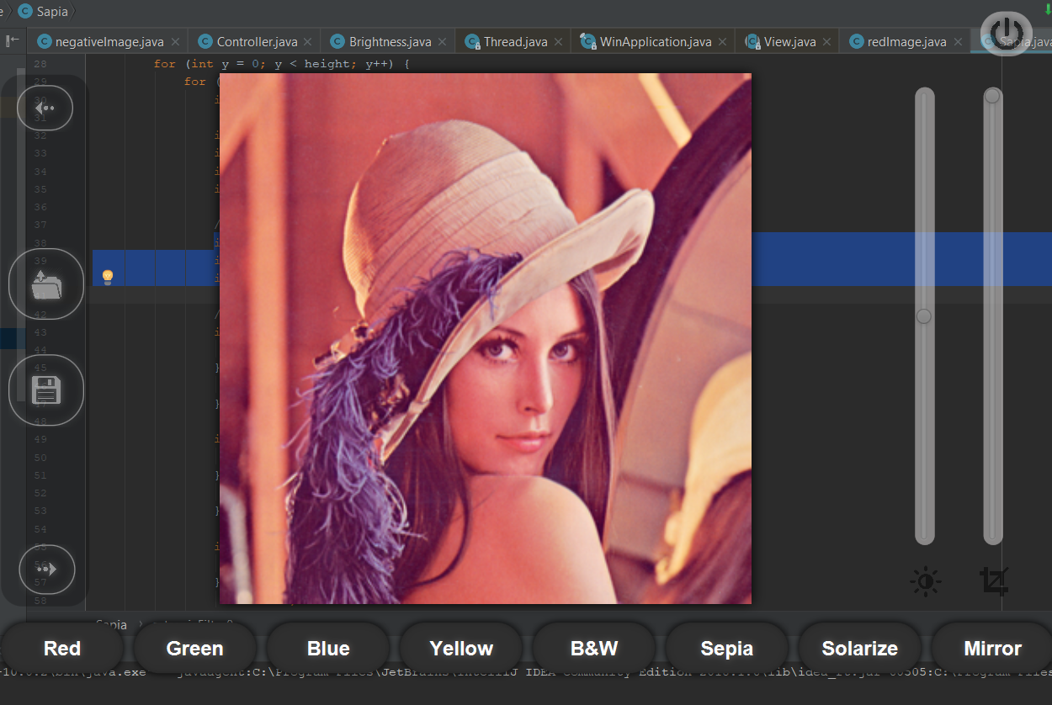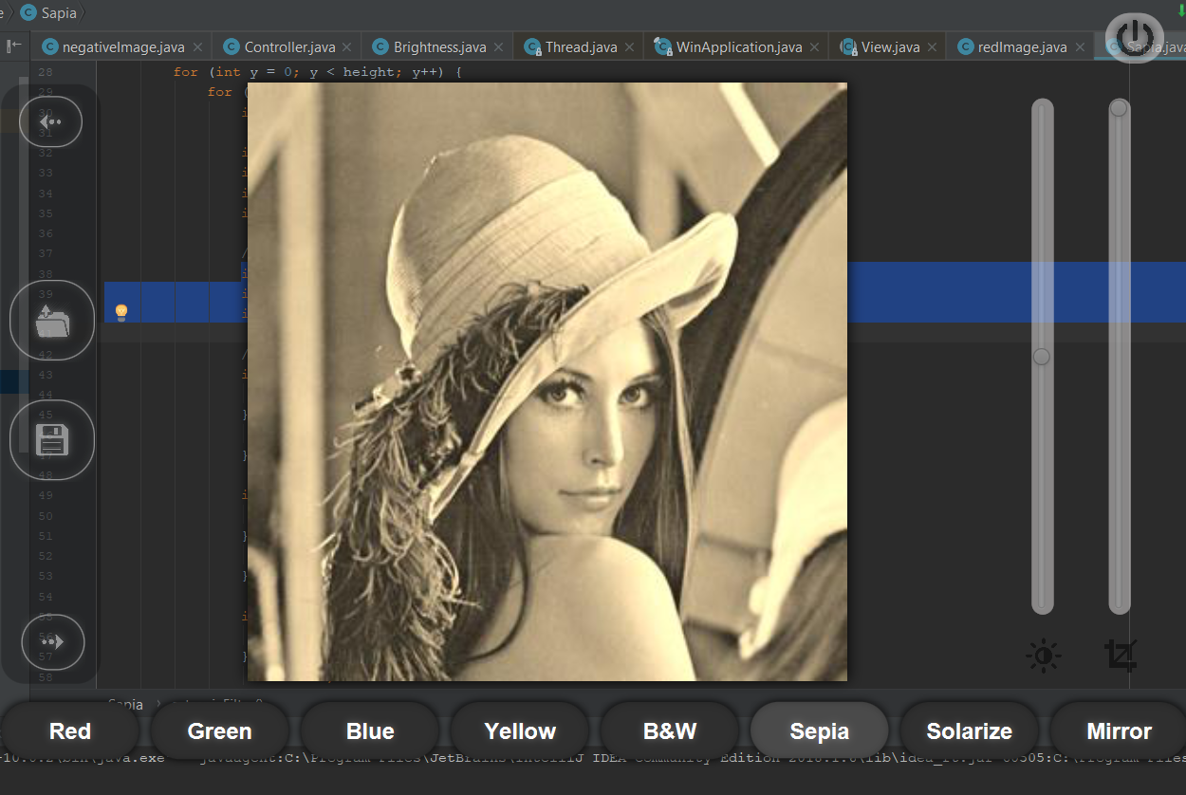

Fig2: sepia image

* + 1. **Black and White**

The easiest transformation is to convert color image into black and white. The average value of red, green, and blue for each pixel is calculated and resets to 0 as if average is closer to 0 and 255 as if closer to 255.

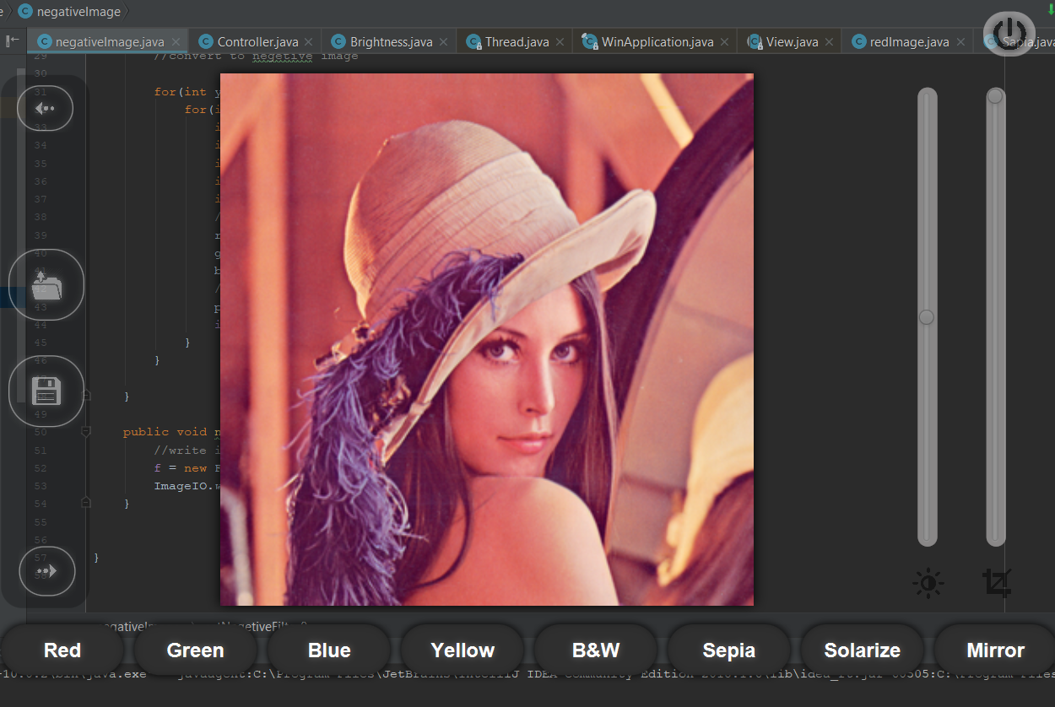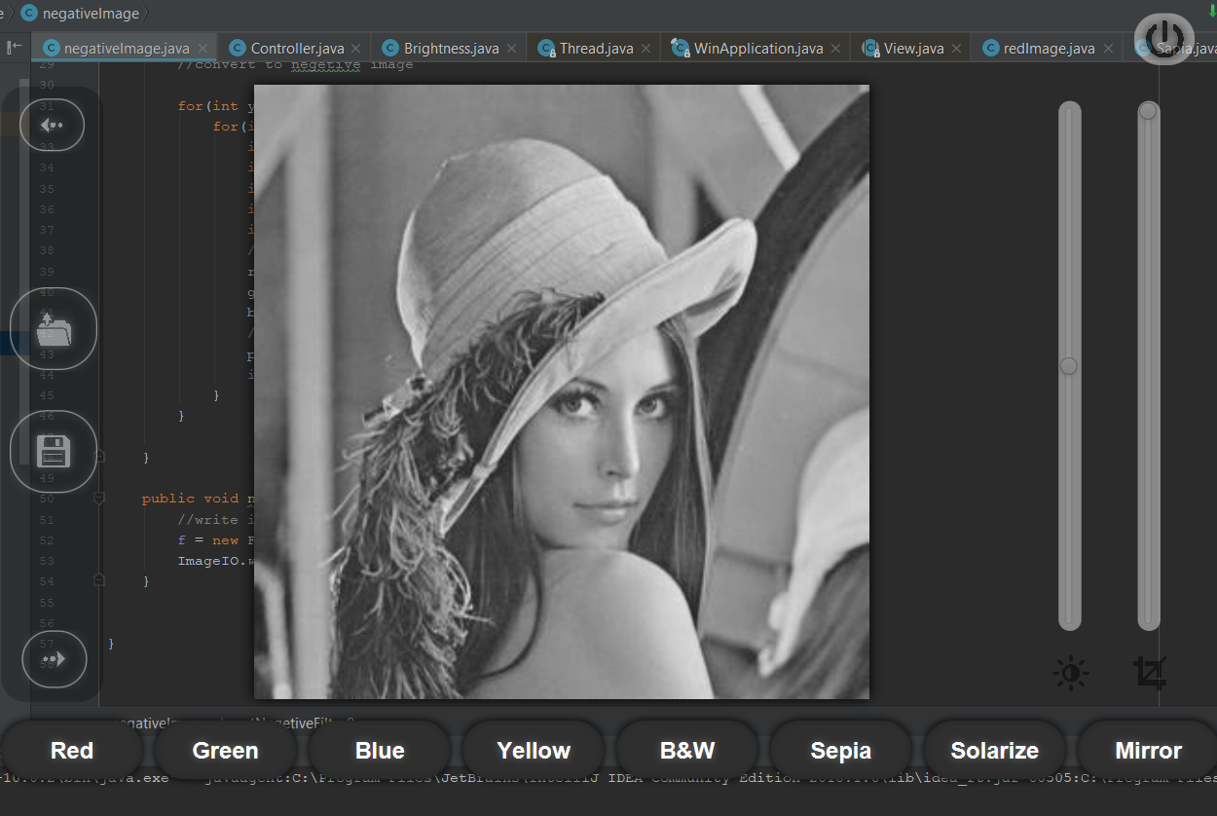

Fig3: Black and White image

* + 1. **Grayscale**

Black and white are not just black and white but also contains various shade of gray called grayscale. The color value for each pixel is replaced by its average value. i.e.

Average = (red + green + blue)/3

red = average

green= average

blue= average

 

Fig4: grayscale image

* + 1. **Solarise**

This filter is similar to photo negative filter but applies ‘V’ shaped transfer function to the image.

if(r <= 127) r = 255-r;  
if(g <= 127) g = 255-g;  
if(b <= 127) b = 255-b;  
p = (a<<24) | (r<<16) | (g<<8) | b;  
img.setRGB(x, y, p);



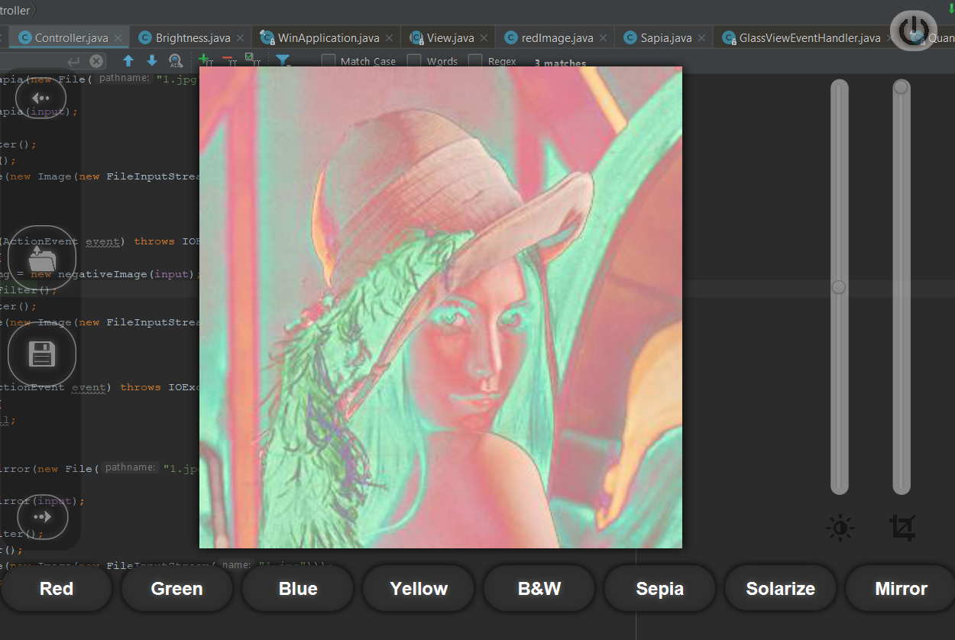 Fig5: solarize image

* + 1. **Negative**

Negative image is image inversion in which light part appears to dark and dark parts appear to be light. The color value of each pixel is subtracted from 255 and is replaced by value formed.



Fig10: photo negative image

* + 1. **Mirror**

This filter mirrors the image horizontally with a graduate transparency. It is horizontal flip.

img.setRGB(x, y, img.getRGB(width - 1 - x, y));  
 img.setRGB(width - 1 - x, y, p);



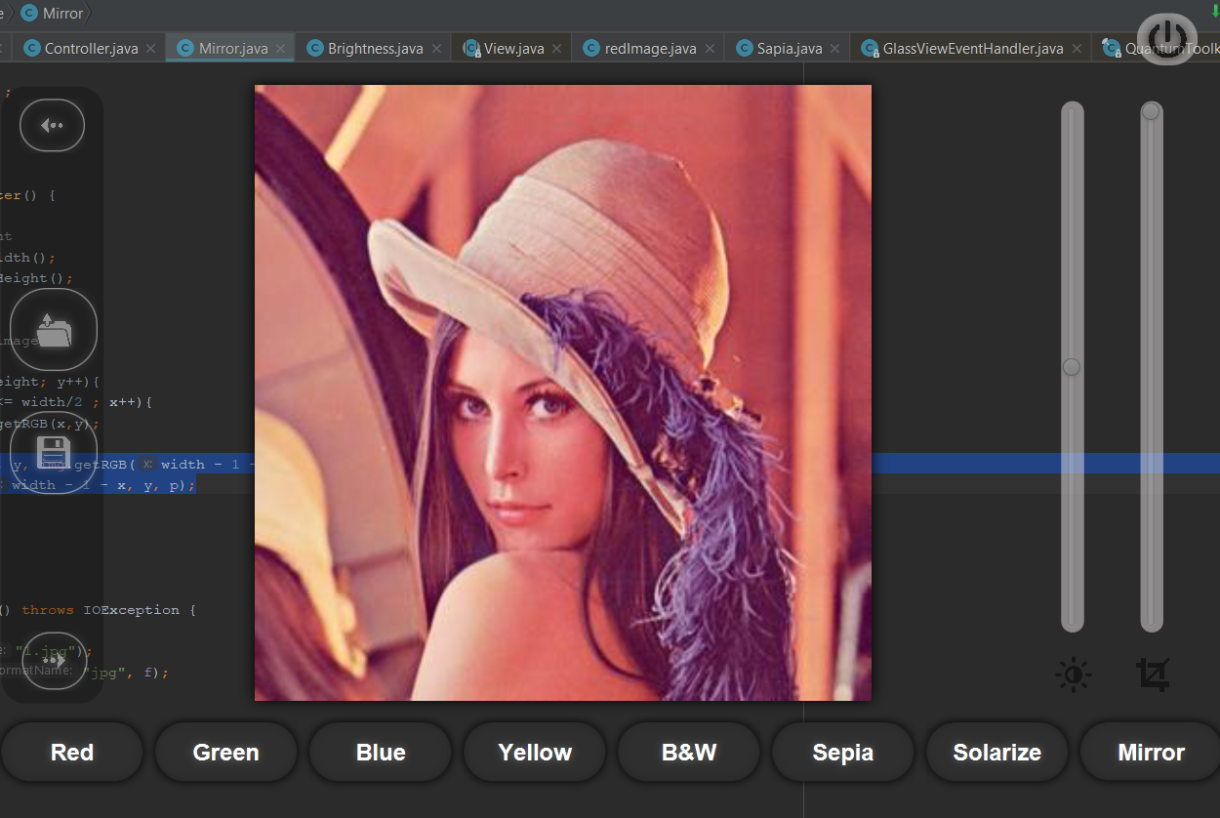

Fig12: mirror image

* + 1. **Crop**

This is a square crop of an image. It crop from center.

int targetWidth = (int)(width * ammount);  
int targetHeight = (int)(height * ammount);  
// Coordinates of the image's middle  
int xc = (width - targetWidth) / 2;  
int yc = (height - targetHeight) / 2;



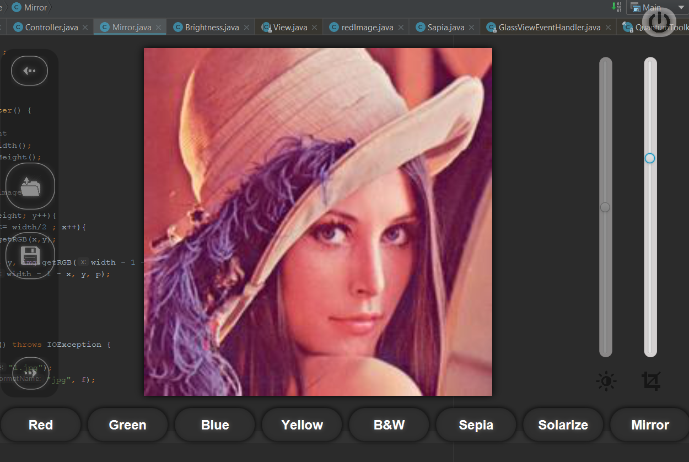

Fig13: crop image

* + 1. **Red**

The green and blue color value of each pixel is set to 0.



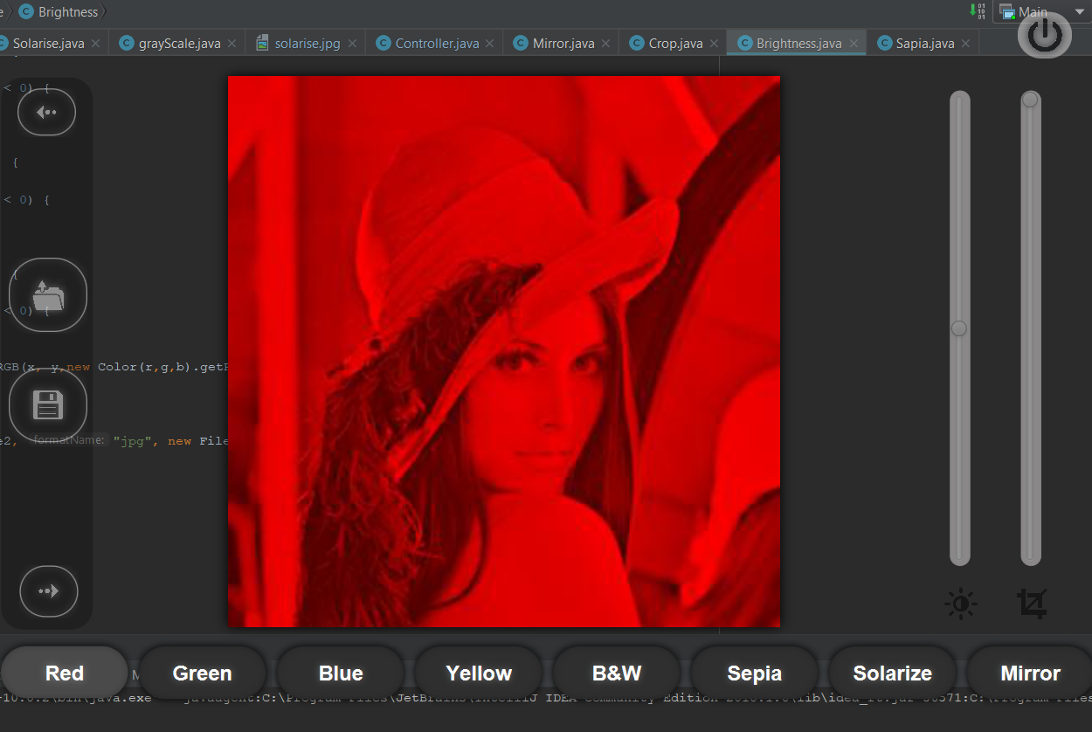 Fig18: red image

* + 1. **Green**

The red and blue color value of each pixel is set to 0.



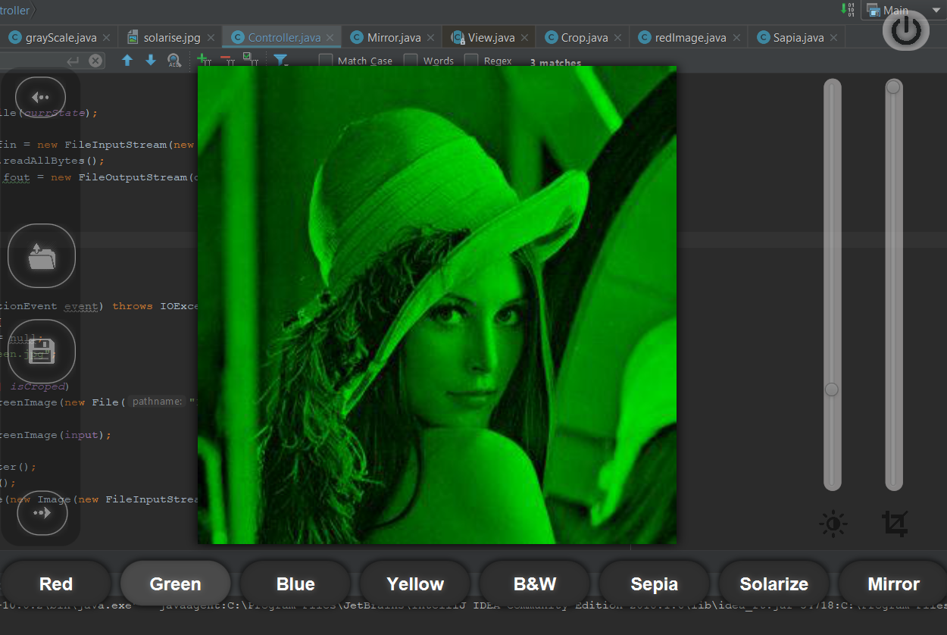Fig19: green image

* + 1. **Blue**

The red and green color value of each pixel is set to 0.



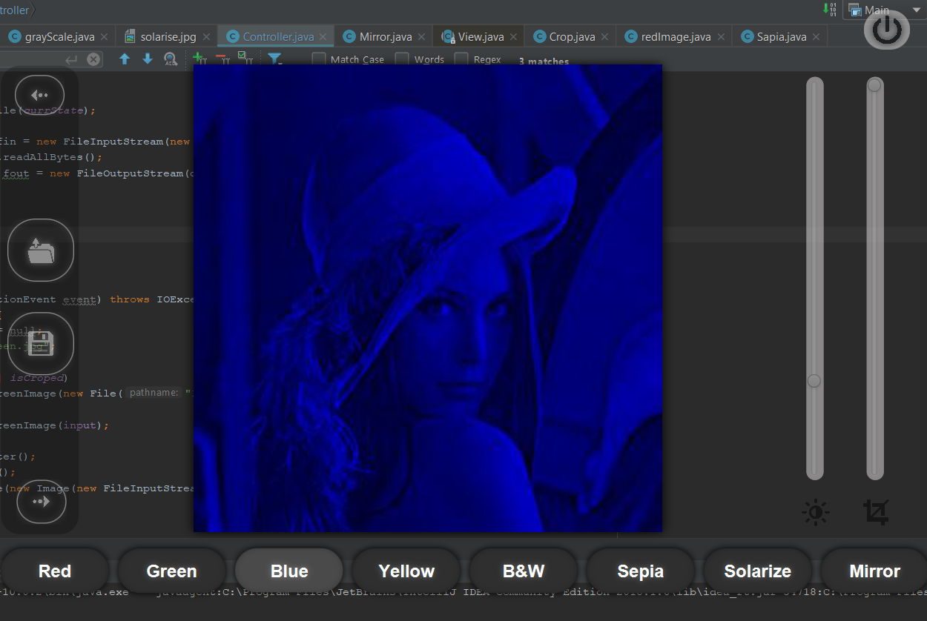Fig20: blue image

* + 1. **Yellow**

The blue color value of each pixel is set to 0.



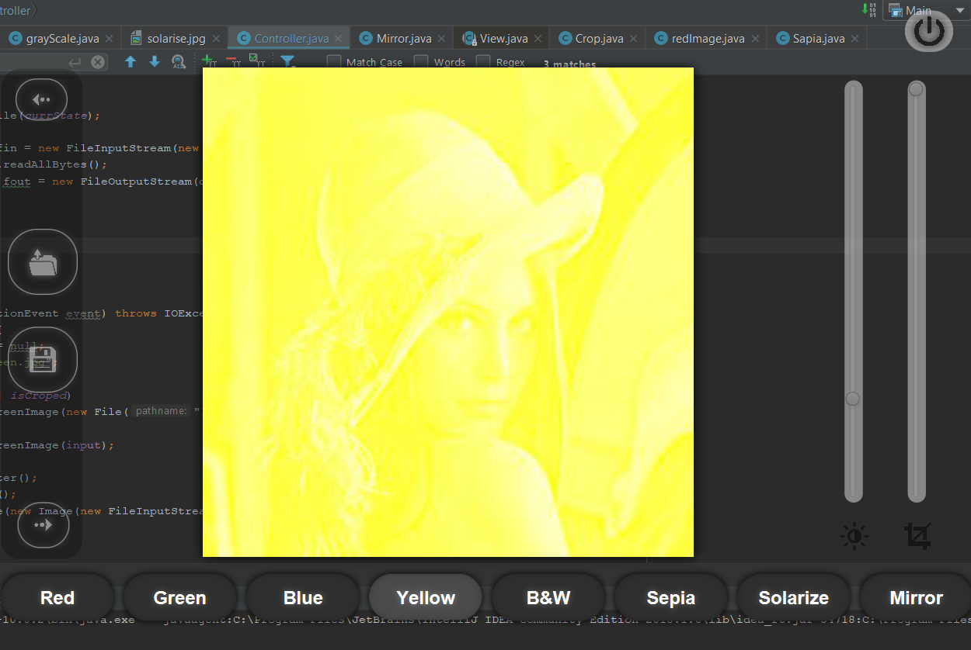Fig23: yellow image

* 1. **Brightness**

Brightness can be simply increased or decreased by simple addition or subtraction, to the image matrix. Certain level of value is added to the color value of each pixel of the image to form new pixel. The resulted image is brightness image of that level.



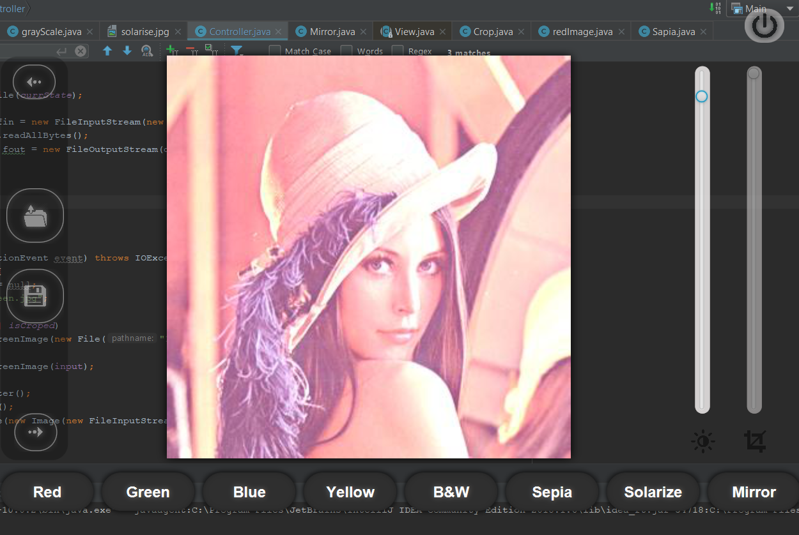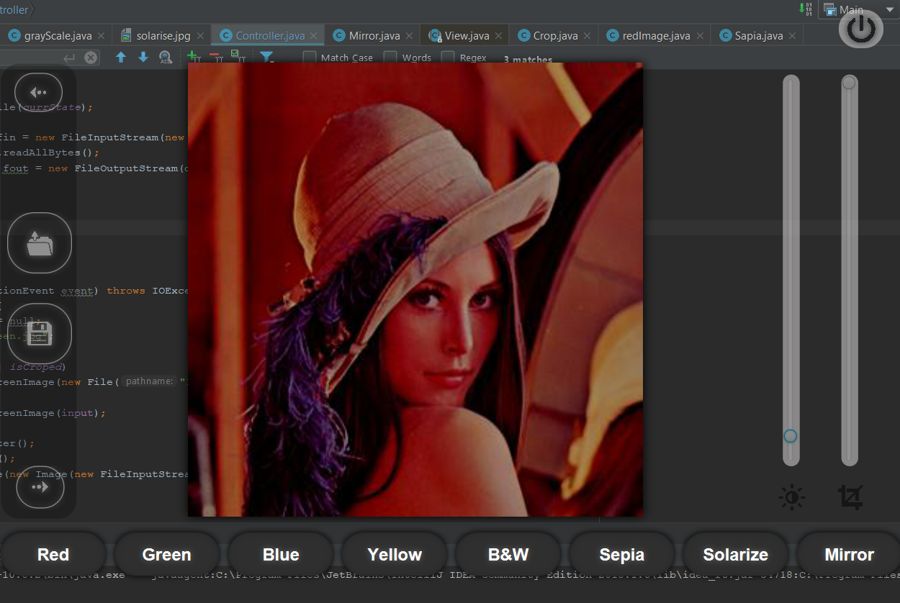 Fig24: brightness image

1. **User Manual**

User have to follow the following instruction to run software. At first user must have to install Java Development Kit (JDK) to their computer. It requires Java Runtime Environment (JRE).

To open the image click ‘Open’ button, then select image and then open it as shown in the figure below.

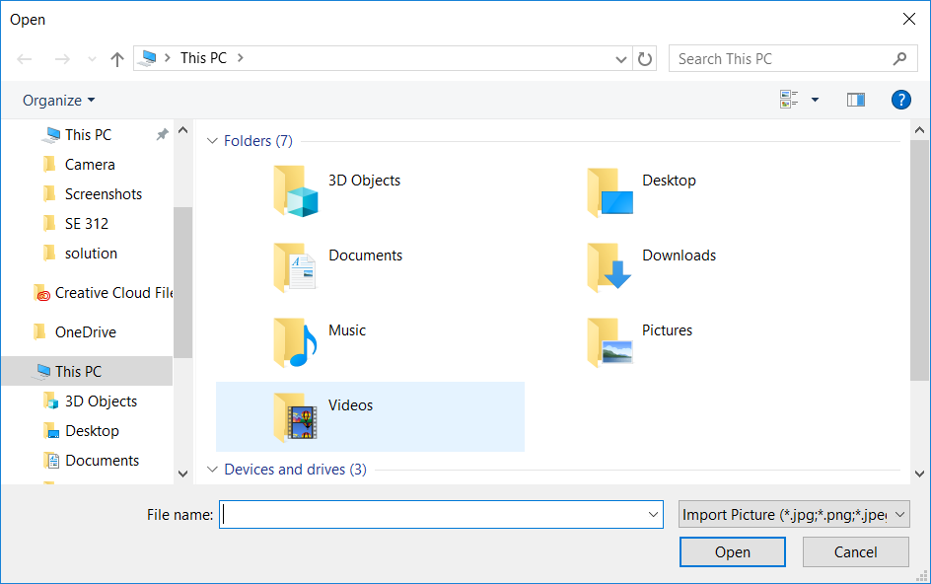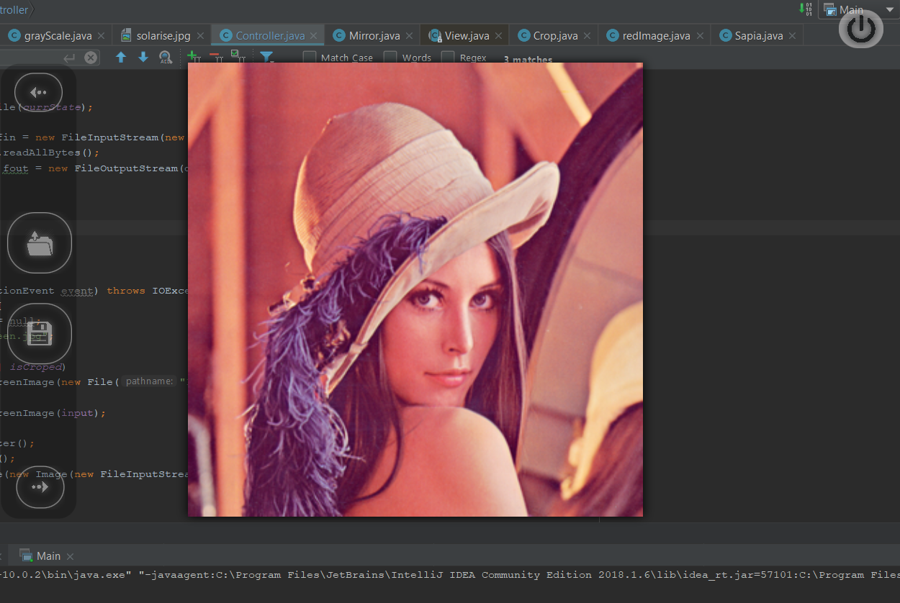

Fig26: open file chooser Fig27: open image

List of filters are given on left, bottom and top of the frame. Click any of them. The left side image will be original image whereas right side image will be the filtered image. It is done in such a way just to compare your filtered image with the original image.

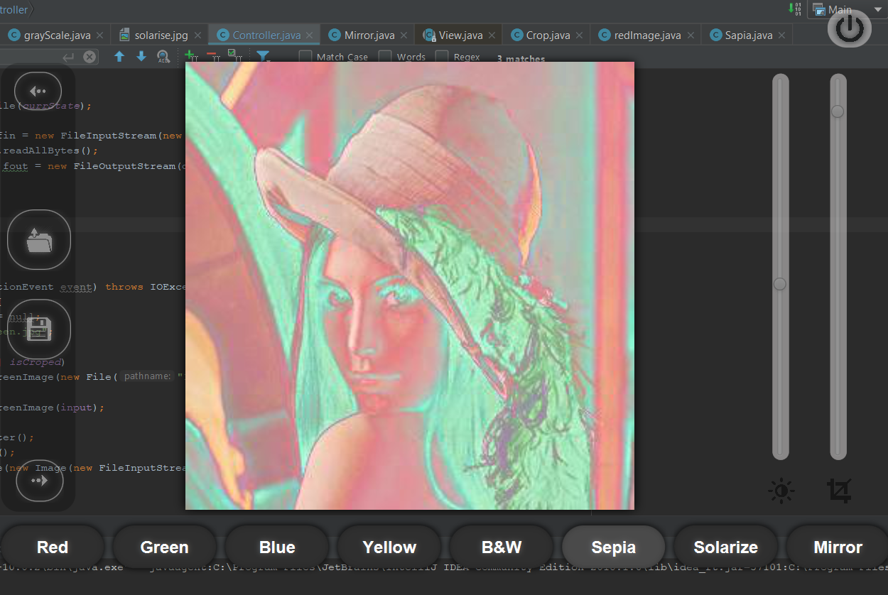

Fig28: filtered image

After having the filtered image we need to save it. Click ‘Save’ button. Save file chooser will appear on the screen, give some name to filtered image e.g. rotated.jpg to save the image.

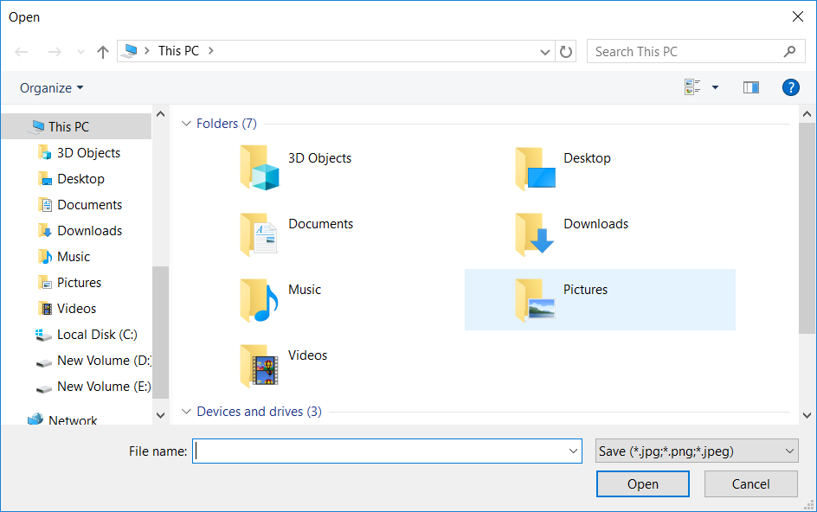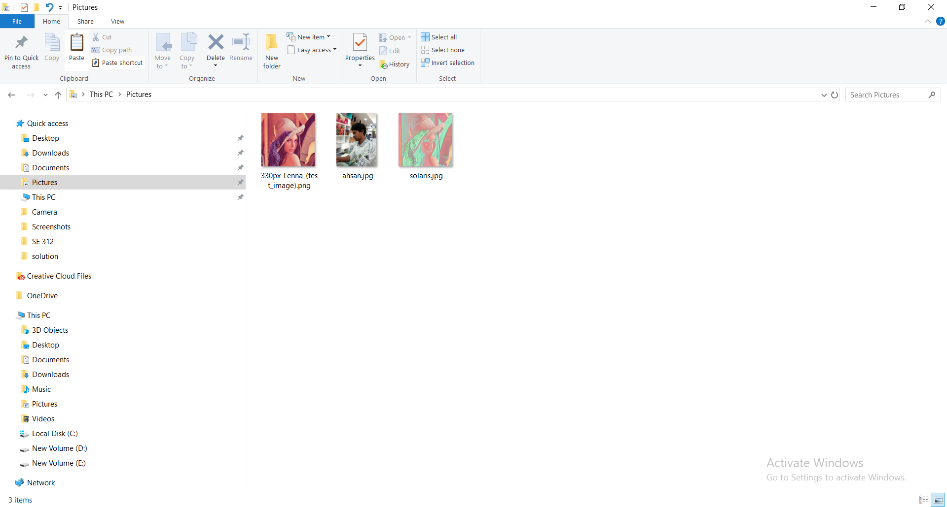

Fig29: save file chooser

1. **Conclusion**

In the ever shrinking world of Information Technology, my project is the humble joint venture to satisfy a small part of Image Processing. There is no claim of being this system perfect. This is just a humble attempt made under trying circumstances. This system has been designed in attractive manner. The software is designed with scalability in mind. Additional modules can be easily added when necessary.

1. **Appendix**

|  |  |  |
| --- | --- | --- |
| **Class Name** | **Lines of code** | **Functionality** |
| Main | 30 | Start the program |
| Controller | 389 | Set button, set anchorpane, set slider, set iamgeview, set image to the anchorpane, save image. |
| Effects | **480** | List of filters: sepia, grayscale, photo negative black and white, solarize, brightness. |
| RGBCMY | 142 | RGB adjustment: red, green, blue, cyan, magenta, yellow. |
| Crop and Brightness | 110 | Cropping an image and it become dark or bright |

Table5: class description

**References:**

1. Java: How to Program, 10th Edition (Deitel): Paul Deitel, Harvey Deitel.
2. [URL: www.cs.umb.edu/~jreyes/csit114-fall-2007/project4/filters.html](http://URL:%20www.cs.umb.edu/~jreyes/csit114-fall-2007/project4/filters.html), “Filters” last accessed on 14 Feb 2019
3. [URL: www.jhlabs.com/ip/blurring.html](http://URL:%20www.jhlabs.com/ip/blurring.html), “Blurring for beginners” last accessed on 20 Apr 2019
4. [URL: www.tutorialspoint.com/dip/index.htm](http://URL:%20www.tutorialspoint.com/dip/index.htm), last accessed on 24 Apr 2019
5. URL: www.javatpoint.com, “Javafx”, last accessed on 23/04/2019